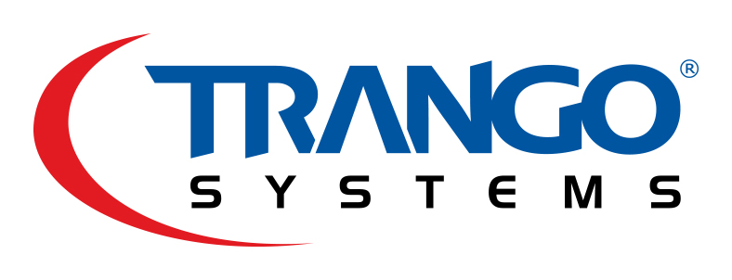
TECHNICAL BRIEF
Ethernet Capacity over Point-to-Point Microwave

Overview
Wireless networks continue to feel the pressure of increased capacity demands from bandwidth intensive devices and users, with no end in sight. Traffic capacity for microwave links is of primary interest to network operators looking to expand their network.
This Technical Brief examines the key parameters to be evaluated when comparing products, as well as detailing methods used to increase capacity.

Radio Link Capacity
For any given channel size, the radio link capacity of the channel is limited to a theoretical maximum per the well known Shannon limit. Modern point-to-point microwave technology uses high order modulation up to 4096QAM to send raw uncoded capacity at 12 bits/symbol. For a 100 MHz channel bandwidth, the theoretical maximum symbol rate is 100 Msym/sec, so the theoretical limit is then:
Capacity = 12 bits/sym x 100 Msym/sec = 1200 Mbits/second.
Two factors reduce the theoretical capacity:
- Filtering – Since it is not possible with current technology to create a brick wall filter, the actual signaling rate must be less than the channel size. In the 100 MHz example, our signaling rate must drop to 88 Msym/sec to fit within the 100 MHz channel and meet FCC and ETSI regulations. Our theoretical maximum is now reduced to 12 bits/Hz x 88 Msym/sec = 1056 Mbps.
- Forward Error Correction (FEC) – Decoding high order modulation in the presence of normal channel noise requires Forward Error Correction techniques. Most products on the market today use one or more of the following FEC methods:
  - Low Density Parity Check (LDPC) – This method has gained popularity since it can offer lower overhead than other methods and increase in receiver sensitivity. The tradeoff with this method is that it can be costly to implement due to the amount of processing power it requires. Trango uses LDPC for all its microwave products. Typical code rates consume around 7% of the capacity available. For our example this would reduce the maximum available capacity from 430 Mbps to (1-.07) x 1056 = 982 Mbps
  - Reed- Solomon (RS) – Although still used in microwave systems due to its simpler design and low cost to implement, when it is the sole method of FEC it has an overhead on the order 18% to achieve reliable operation. At 18% overhead, our example capacity would reduce to (1-.18) x 1056 = 865 Mbps
Trango uses LDPC plus light Reed Solomon coding to enhance data robustness at the highest modulations of 2048 and 4096QAM. The net combined overhead is roughly 11%. For all lower modulations only LDPC is used.

Throughput Confusion
When verifying actual Ethernet throughput performance, it is very important to understand what the test data really represents. RFC2544 is a standard test method for measuring capacity, latency and burst performance. It is widely used to obtain performance numbers for Layer 1(Physical), Layer 2(MAC), and Layer 3(IP) traffic.
Many dedicated products are available that can perform fully automated RFC2544 throughput tests at up to full line rate. These are preferred over software solutions running on standard PCs or Linux Hosts which may not be accurate depending on the loading of the CPU.
Tools such as Iperf are acceptable provided they are used on dedicated fast CPUs and are tested with no radio link first to ensure the capacity is high enough.
Layer 1 vs. Layer 2 vs. Layer 3
Some confusion between manufacturer stated performance can be attributed to comparing Layer 1(L1) with Layer 2(L2) test results. L1 numbers will always look more impressive than L2 results because the preamble and Frame Check Sequence (FCS) are included in the calculation – this will especially be noticeable with small packet L2 test results since the preamble and FCS are a larger percentage of the overall packet.
At 64 byte L2 frame sizes, the L1 capacity of a full Gigabit system is 1 Gbps, but the corresponding L2 rate is only 761.9 Mbps. This is the physical limit of 1000BaseT or 1000BaseX fiber.

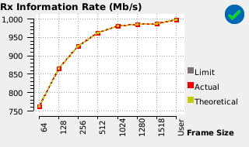
<Maximum Layer 2 Throughput for a Full Gigabit Layer 1 Link>

Layer 2 throughput is what most equipment manufacturers specify and what is generally accepted by service providers.
Trango uses specialized test equipment capable of line rate capacity for all packet sizes, and always provides Layer 2 performance numbers for easy comparison to actual test that are run in the field.

FDD vs TDD
Licensed microwave equipment is almost always Frequency Division Duplexed (FDD), meaning that upstream traffic is sent on a dedicated frequency and downstream traffic is sent on a SEPARATE dedicated frequency – two frequencies are used simultaneously.
Capacity numbers for FDD systems are traditionally provided as one way capacities. For example, a stated capacity of 1 Gbps Full Duplex means that 1 Gbps can be sent upstream at the same time that 1 Gbps can be sent downstream.
For service providers familiar with Time Division Duplex (TDD) systems, this can create some confusion. TDD systems send upstream and downstream traffic on the same RF channel, allocating time slots for each direction. Typically TDD capacities are given as aggregate numbers which is the sum of upstream and downstream capacity.
To remove confusion, many microwave suppliers specify both the Full Duplex numbers and the aggregate numbers on their datasheets. For symmetric FDD microwave systems, the aggregate numbers are twice the stated FDD numbers.

Summary
When evaluating the capacity of a microwave consider the following:
- Compare apples to apples: Compare FDD capacity for Layer 2 frame sizes of 64 to 9600 bytes using RFC2544 test methods.
- Make sure that all frame sizes are tested. Equipment that passes traffic through a CPU instead of using a dedicated switch will most likely have severe reduction in capacity for smaller packet sizes.
- Make sure the RFC2544 test durations are more than 1 second. Large switch buffers can absorb bursts of traffic and make the calculation of real throughput higher than reality for a continuous stream of traffic.

For more information contact Trango Systems or visit our web site at www.trangosys.com.

About Trango Systems, Inc.
Trango Systems, Inc., was founded in 1996 and is headquartered in San Diego County, California. The company designs and manufactures innovative licensed and unlicensed microwave backhaul equipment for customers in over 70 countries and is ISO 9001:2008 certified.

